**Aim-** To make a EC2 Machine in AWS

# THEORY-

Amazon Elastic Compute Cloud (Amazon EC2) is a web service that provides secure, resizable compute capacity in the cloud. It is designed to make web-scale cloud computing easier for developers.

# STEPS-

LOGIN TO AWS ACCOUNT, THEN SEACH EC2.

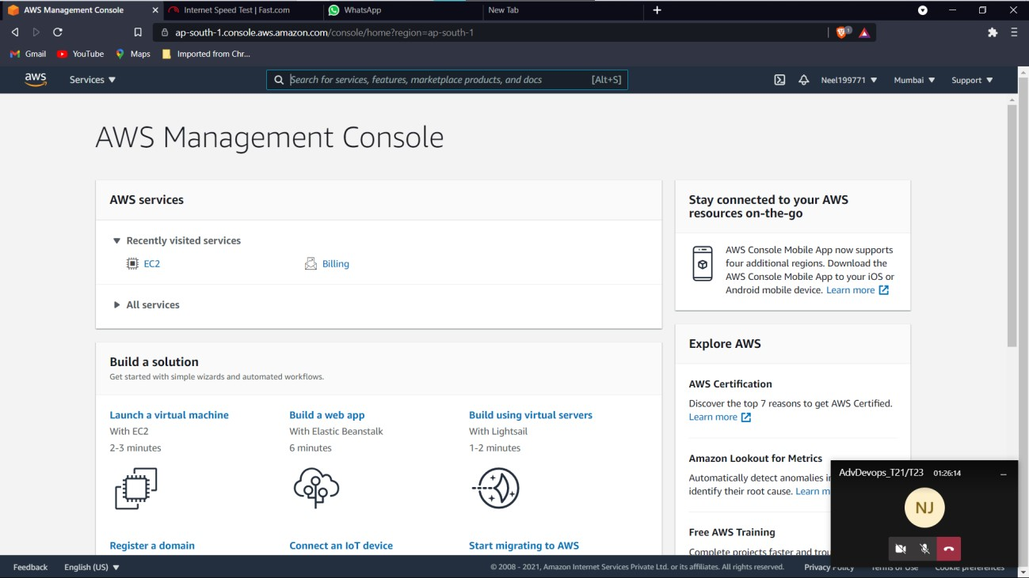

NOW CLICK ON LAUNCH / CREATE NEW INSTANCES.

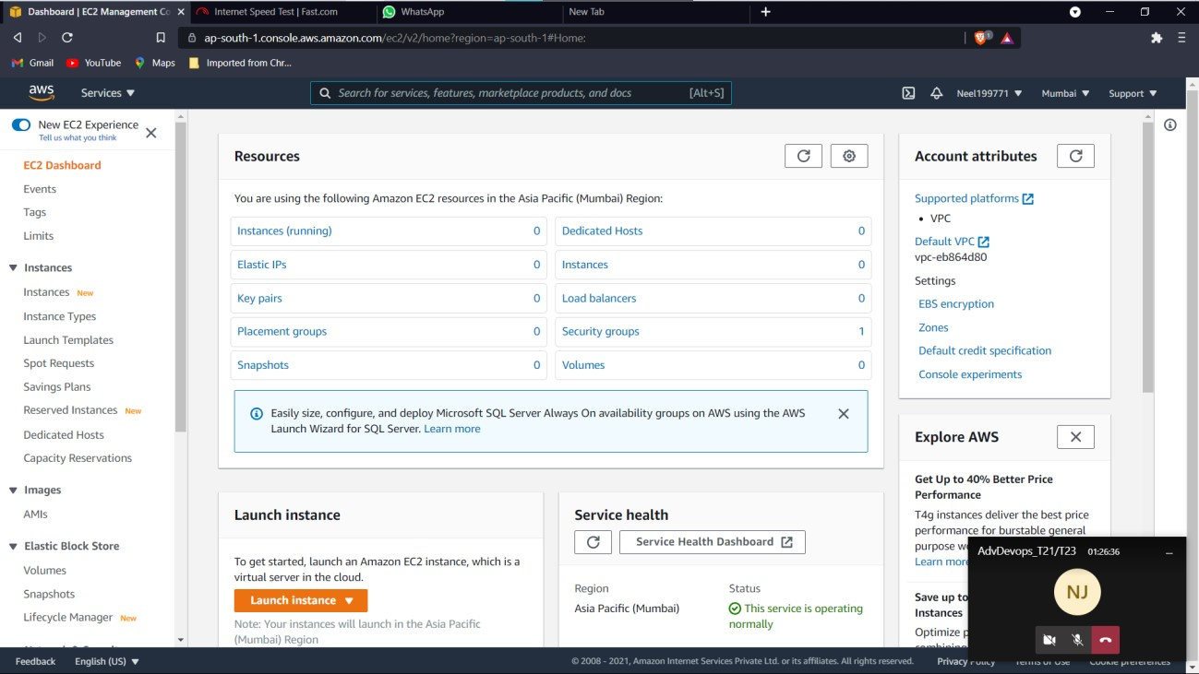

Choose any machine you want to create here I am creating UBUNTU(free tier).

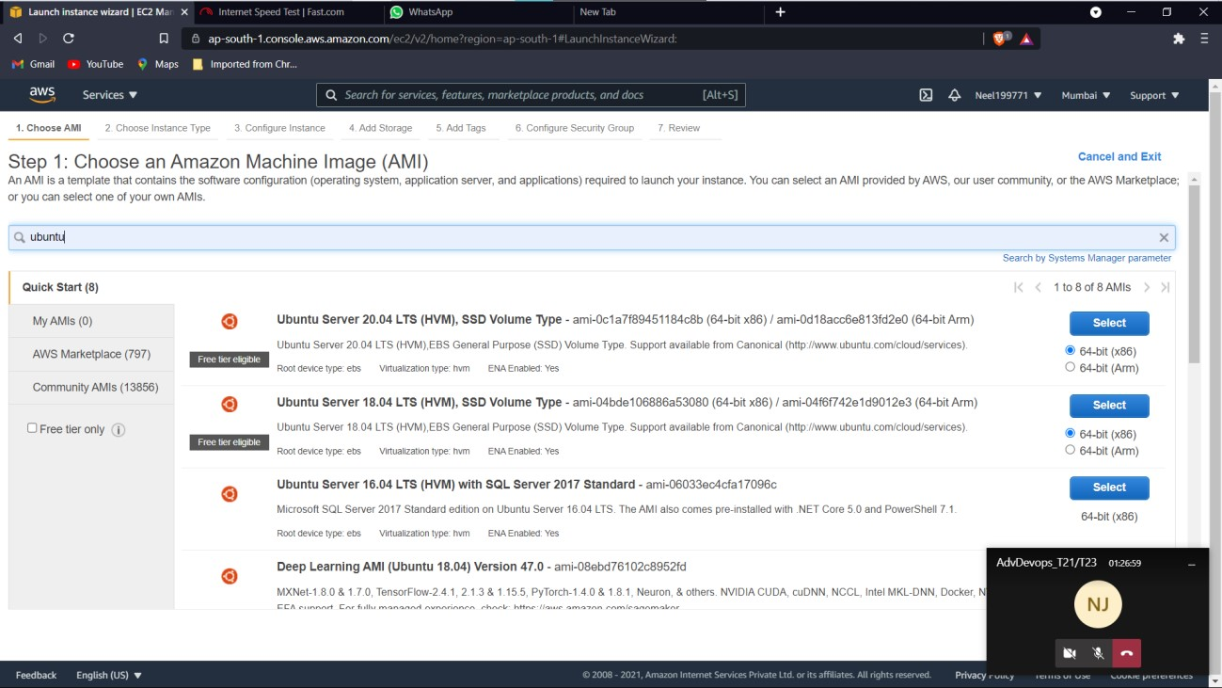

Click on T2 micro (free tier one)

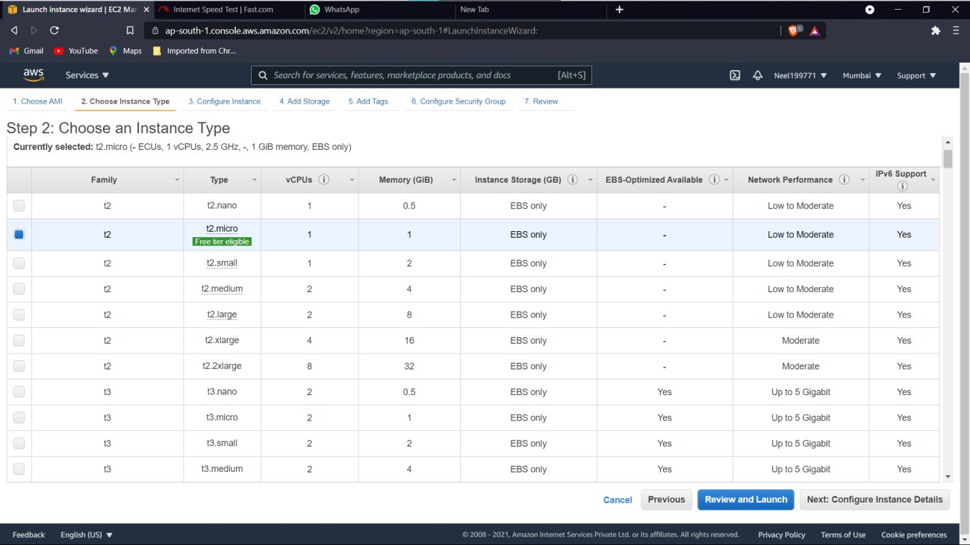

Click on NEXT, then Again Click Next.

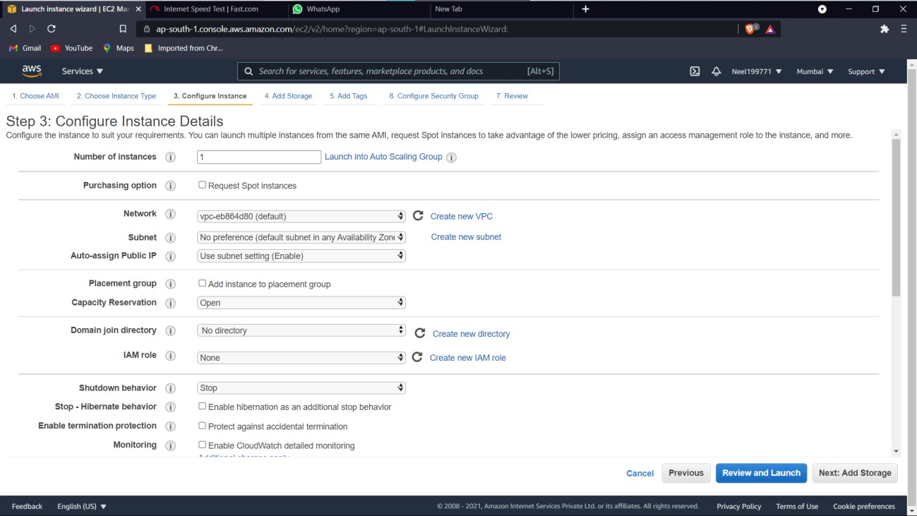

THEN CREATE A KEY PAIR BY ANY NAME AND DOWNLOAD IT. THEN CLICK NEXT

Now add security group ALL TRAFFIC ,

PROTOCOL – ALL,

SOURCE- ANYWHERE.

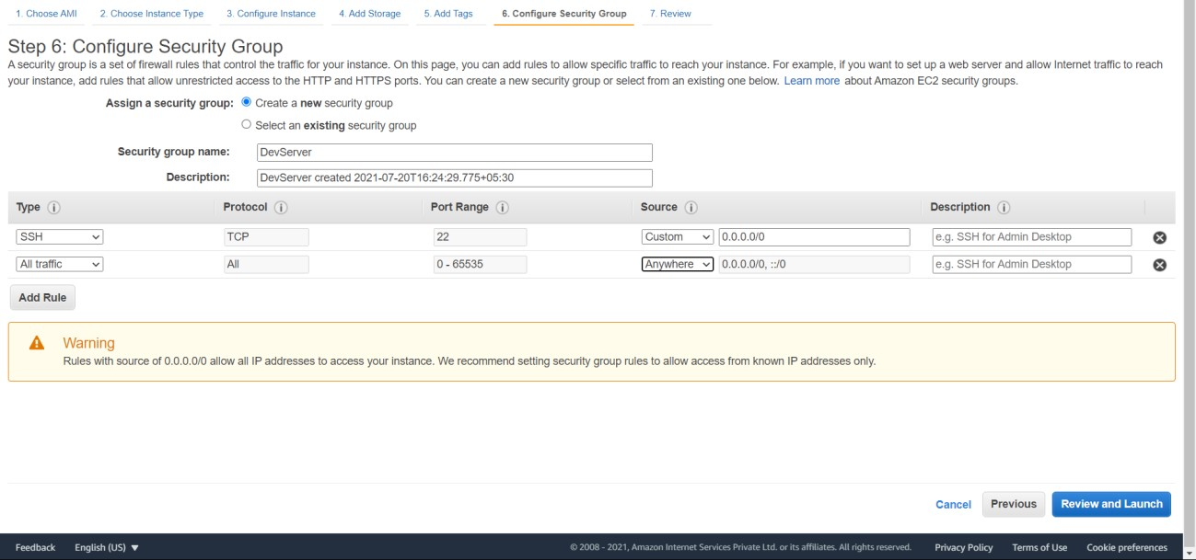

NOW WAIT TILL THE STATUS CHECK IS 2/2 and Instance is running.

Once Check is complete click on launch instances.

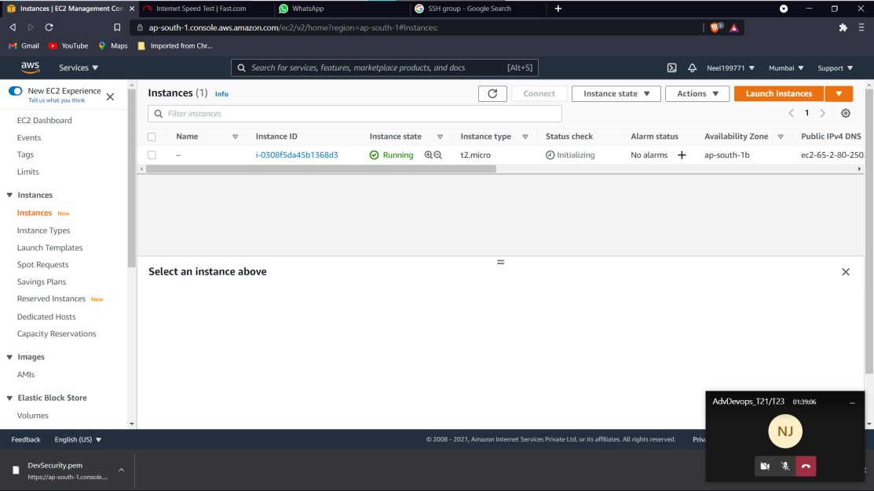

FOLLOW SOME BASIC LINUX COMMANDS AS SHOWN BELOW-

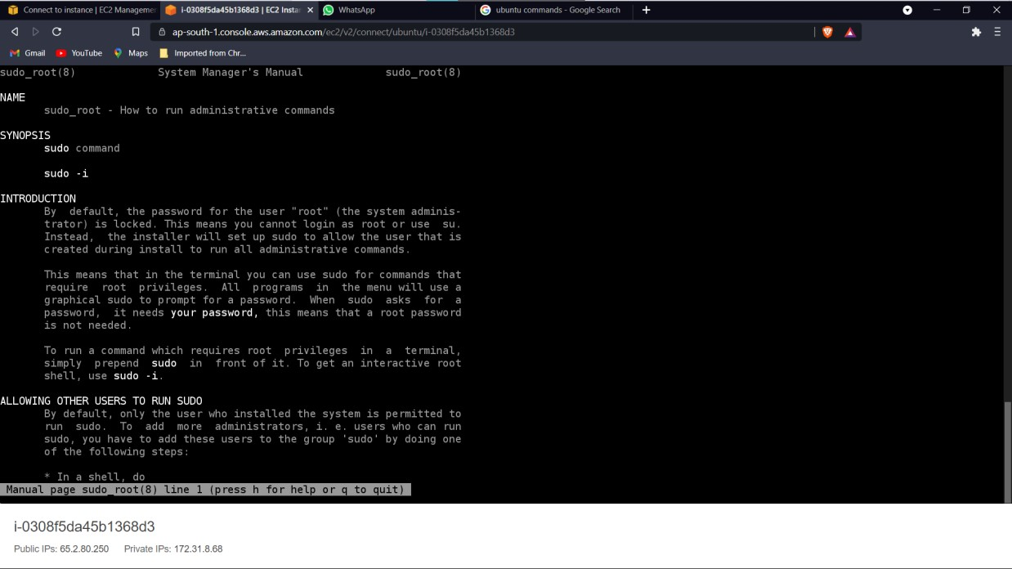

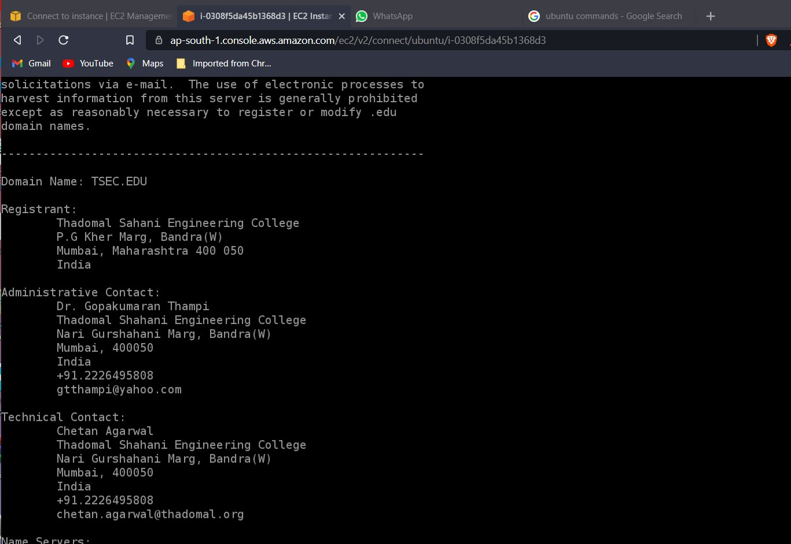

**CONCLUTION –** HENCE LEARNED AND IMPLEMETED THE STEPS TO CREATE AN EC2 MACHINE.